**Assignment 3**

|  |  |
| --- | --- |
| Assignment Date | 31 October 2022 |
| Student Name | Aishwarya R |
| Student Roll Number | 311019104006 |
| Maximum Marks | 2 Marks |

**Question 1:** Create a bucket in IBM object storage.

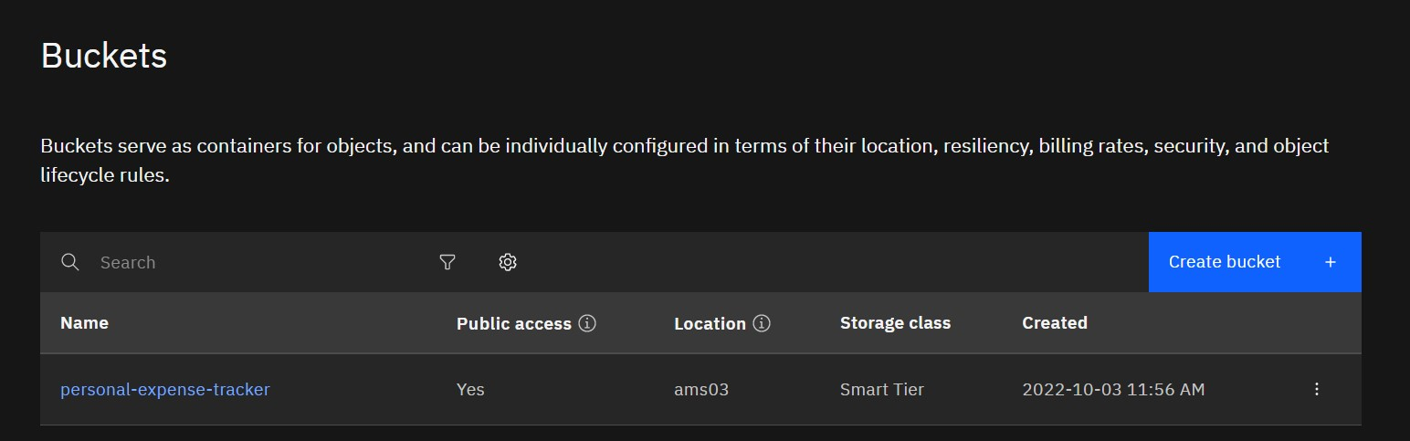2022-10-31

**Question 2:**

Upload any 5 images to IBM object storage and make it public. Write HTML code to displaying all the 5 images

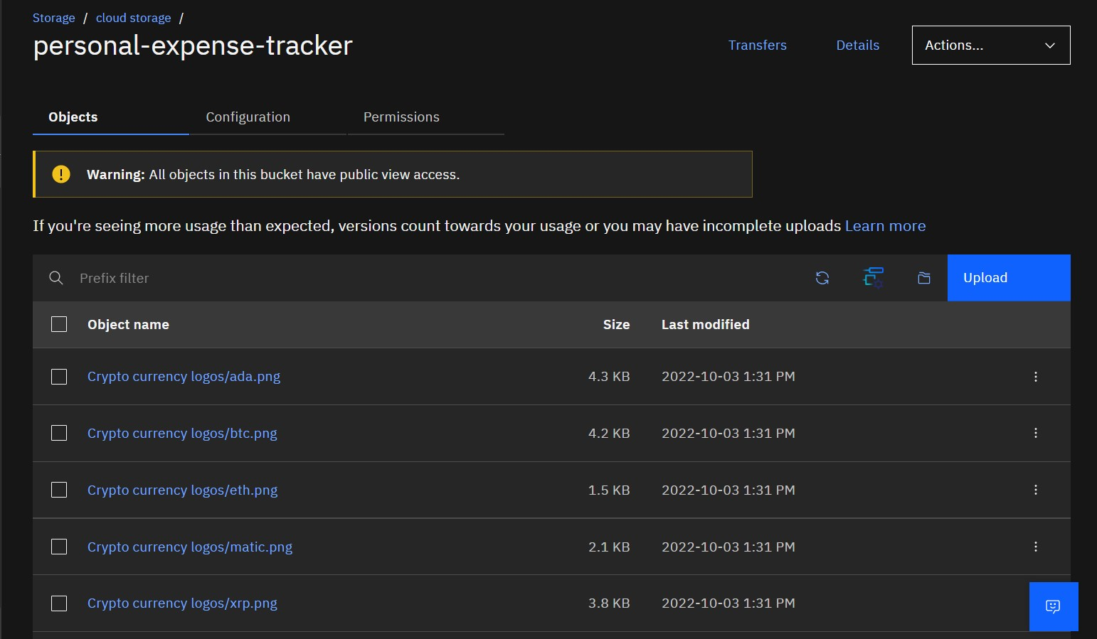2022-10-31

2022-10-31

2022-10-31

2022-10-31

2022-10-31

HTML code for displaying images in cloud

|  |
| --- |
| <!DOCTYPE html>  <html lang="en" dir="ltr">  <head>  <meta charset="utf-8">  <title>Crypto currencies</title>  </head>  <body>  <h1>Popular Cryptocurrencies</<h1>  <h2>1 Bitcoin BTC </h2>  <img src="https://personal-expense-tracker.s3.ams03.cloud-object-storage.appdomain.  cloud/Crypto%20currency%20logos/btc.png" alt="Bitcoin">  <h2>2 Ethereum ETH</h2>  <img src="https://personal-expense-tracker.s3.ams03.cloud-object-storage.appdomain.  cloud/Crypto%20currency%20logos/eth.png" alt="Ethereum">  <h2>3 Polygon MATIC</h2>  <img src="https://personal-expense-tracker.s3.ams03.cloud-object-storage.appdomain.  cloud/Crypto%20currency%20logos/matic.png" alt="Polygon">  <h2>4 Ripple XRP</h2>  <img src="https://personal-expense-tracker.s3.ams03.cloud-object-storage.appdomain.  cloud/Crypto%20currency%20logos/xrp.png" alt="XRP">  <h2>5 Cardano ADA</h2> |
| <img src="https://personal-expense-tracker.s3.ams03.cloud-object-storage.appdomain.  cloud/Crypto%20currency%20logos/ada.png" alt="Cardano">  </body>  </html> |

HTML Output for displaying images from IBM cloud storage:

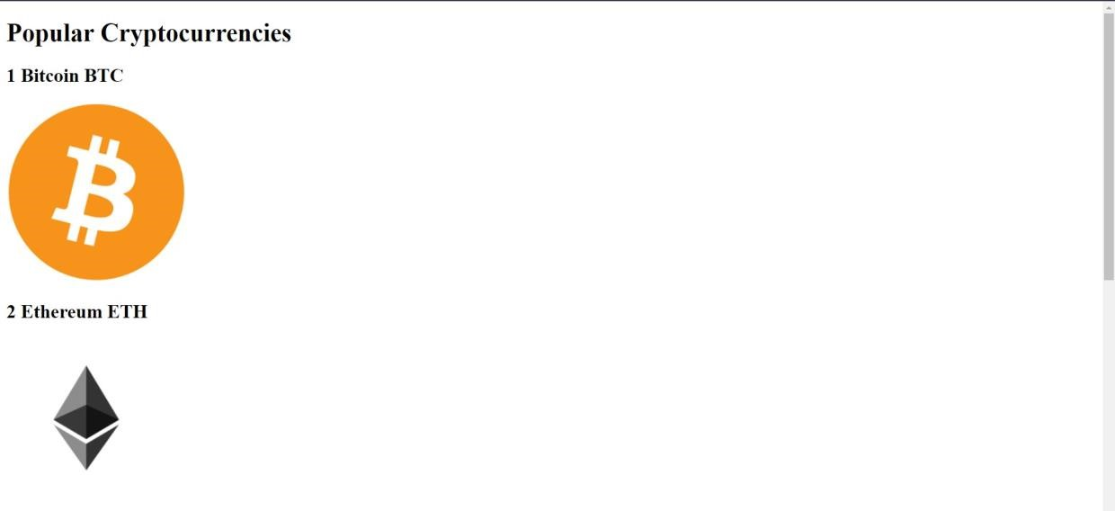

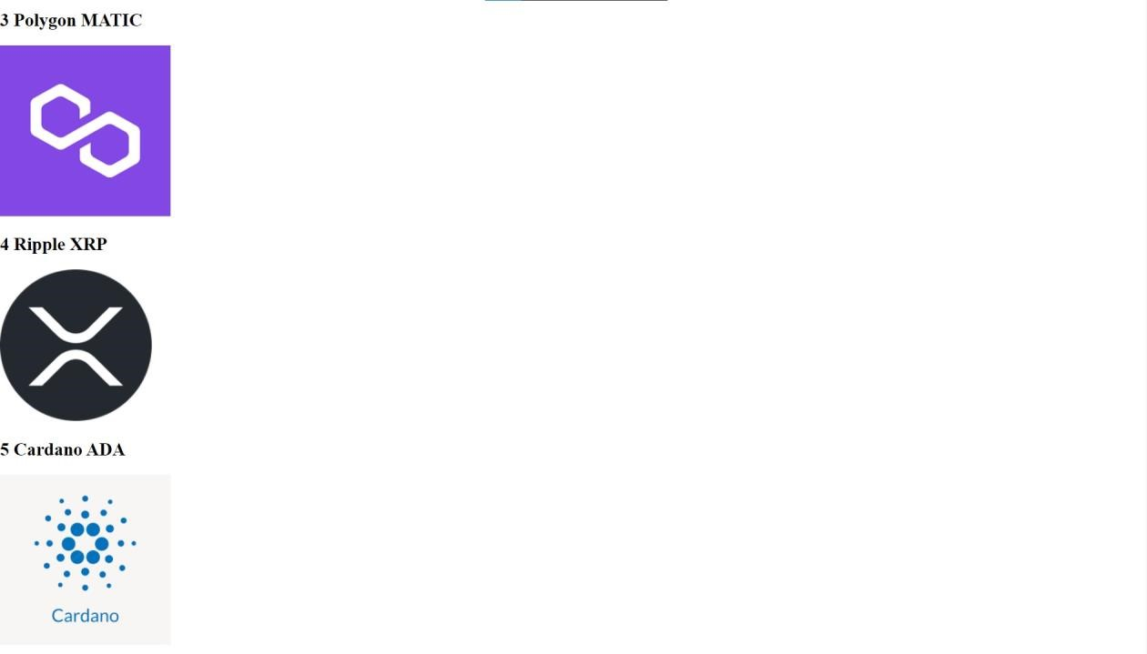

**Question 3:**

Upload a CSS page to the object storage and use the same page in your HTML code. HTML code with CSS file present in IBM cloud storage:

|  |
| --- |
| <html>  <head>  <title>Home page</title>  <link rel="stylesheet" href="https://personal-expense-tracker.s3.ams03.cloud-object-storage.appdomain  .cloud/style.css">  </head>  <body>  <h1>Hi there</h1> |
| <p>Here is the CSS file present in IBM cloud storage <a href="https://personal-expense-tracker.s3.ams03.cloud-object-storage.appdomain  .cloud/style.css">Click here</a></p> </body>  </html> |

HTML code output:

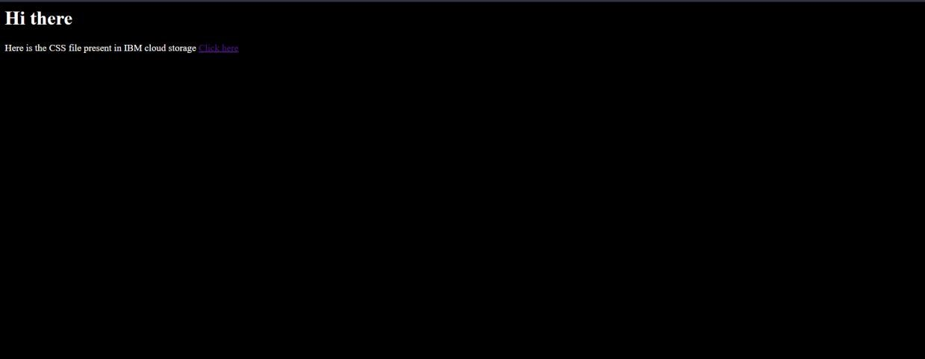

CSS file in Cloud object storage

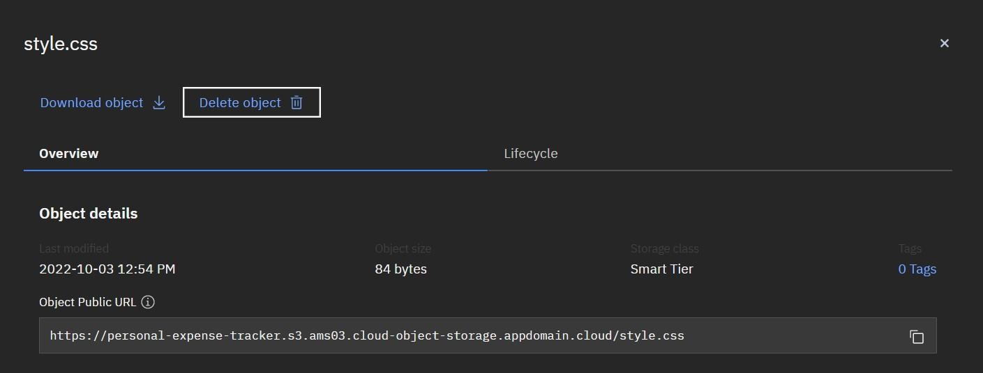2022-10-31

**Question 4:**

Design a chatbot using IBM Watson assistant for hospital. Ex: User comes with query to know the branches for that hospital in your city. Submit the web URL of that chat bot as a assignment.

**Web URL of chat box:**

[https:*/* web-chat.global.assistant.watson.appdomain.cloud/preview.html?ba ckgroundImageURL=https%3A%2F%2Fjp-tok.assistant.watson.cloud.ibm.co m%2Fpublic%2Fimages%2Fupx-f3a1f015-5572-4204-96b6-7c25f885ddc6 %3A%3A156bcb72-665e-46b3-872e-a17217657433&integrationID=d2b5](https://web-chat.global.assistant.watson.appdomain.cloud/preview.html?backgroundImageURL=https%3A%2F%2Fjp-tok.assistant.watson.cloud.ibm.com%2Fpublic%2Fimages%2Fupx-f3a1f015-5572-4204-96b6-7c25f885ddc6%3A%3A156bcb72-665e-46b3-872e-a17217657433&integrationID=d2b53d34-6e0e-4d81-b157-ae1023cd641a&region=jp-tok&serviceInstanceID=f3a1f015-5572-4204-96b6-7c25f885ddc6)

[3d34-6e0e-4d81-b157-ae1023cd641a&region=jp-tok&serviceInstanceID=f](https://web-chat.global.assistant.watson.appdomain.cloud/preview.html?backgroundImageURL=https%3A%2F%2Fjp-tok.assistant.watson.cloud.ibm.com%2Fpublic%2Fimages%2Fupx-f3a1f015-5572-4204-96b6-7c25f885ddc6%3A%3A156bcb72-665e-46b3-872e-a17217657433&integrationID=d2b53d34-6e0e-4d81-b157-ae1023cd641a&region=jp-tok&serviceInstanceID=f3a1f015-5572-4204-96b6-7c25f885ddc6)

[3a1f015-5572-4204-96b6-7c25f885ddc6](https://web-chat.global.assistant.watson.appdomain.cloud/preview.html?backgroundImageURL=https%3A%2F%2Fjp-tok.assistant.watson.cloud.ibm.com%2Fpublic%2Fimages%2Fupx-f3a1f015-5572-4204-96b6-7c25f885ddc6%3A%3A156bcb72-665e-46b3-872e-a17217657433&integrationID=d2b53d34-6e0e-4d81-b157-ae1023cd641a&region=jp-tok&serviceInstanceID=f3a1f015-5572-4204-96b6-7c25f885ddc6)

|  |  |
| --- | --- |
| Watso a Assistant | — |

|  |
| --- |
| appointment booking |

|  |
| --- |
| ftotkata |

Welcome, how can I assist you?

please select the preferred branch location

Delhi Mumbai Chennai

Please select the preferred timing for appointment.

9:30 am 11:30 am 2:3O pm

5:00 pm

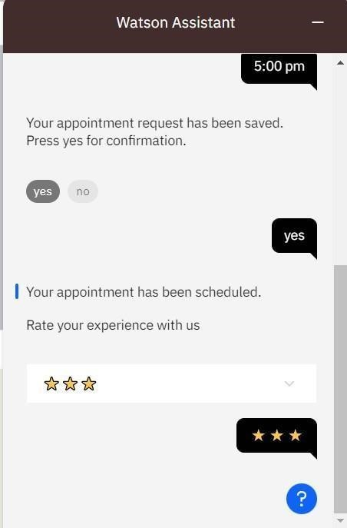

**Question 5:**

Create Watson assistant service with 10 steps and use 3 conditions in it. Load that script in HTML page.

Script in HTML page:

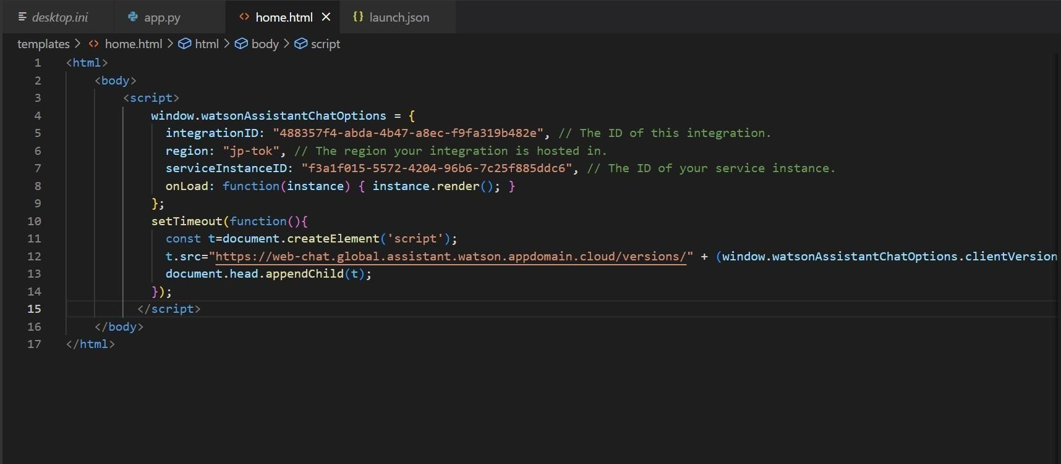

Food-ordering bot:

# Watson Assistant

Welcome, how clan I assist you?

order food



Select the food item







# Watson Assistant

For delivery we will need a few pieces of information. Let me guide you through this process!

First, please provide your first name.



Thanks! Now, enter your last name.

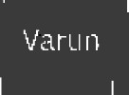

Awesome. I’ll also need an email address associated with your new account. We will send you the delivery details to your email

Which email address would you like to use?



|  |
| --- |
| th Street Manhattan newtown |

|  |
| --- |
| Yes, I'll like to add a i›hone number. |

|  |
| --- |
| l234o6789 |

# Watson Assistant

Enter the delivery location

We need your iphone number to contact you.

Would you like to do so?

Yes, I'd like to add a phone numbers

O kay, please enter your phone number below.

Watson Assistant —

Please enter a valid who ne nrim bei.



T hands! Docs the following ng information look correct? If so, I Will proceed to placing your order

* Name: Doobie
* Email Address: doobie@gmail.com
* Phone Number: 6482973043
* Delivery Location: 14th Street Manhattan



## Watson Assistant —

* Email Address:doobie@gmail.com “
* Phone Number: 6482973043
* Delivery Location: 14th Street Manhattan

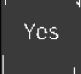

Your order will delivered within 3 0 mins ! You will receive an email conformation shortly.

We SCO 0!

